**Shell Script Assignment**

**1.Create a script named “myscript” in current directory to do the following.**

**a)display “hello user”**

**Ans:**

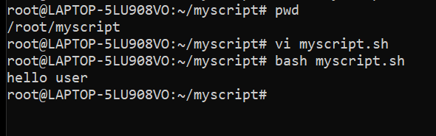

**b)List files in current directory**

**Ans:**

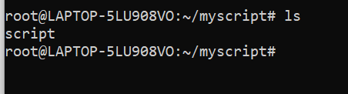

**c) Name of logged in user**

**Ans:**

vi newscript.sh

Go to insert mode->press #!/bin/sh-> enter echo “$USER”->cmd mode->:wq-> press echo $USER->root is the user name

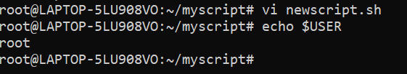

**d) Date**

**Ans: vi dt -> -> date > dt -> vi dt**

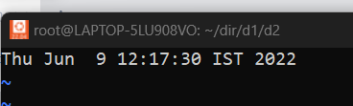

**2.Add execute permission and Run the script from**

**a)current directory**

**Ans:**

**Chmod +x myscript.sh**

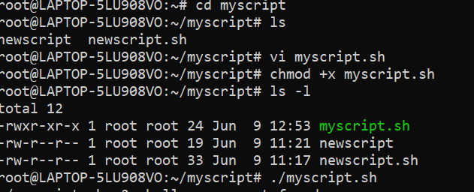

1. **Create a subdirectory named “test”**

**Ans: mkdir -p temp1/test**

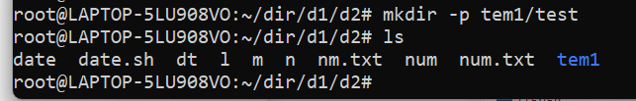

1. **Change to “test” directory. Run the script “myscript” [Hint: You will have to update PATH to include the directory containg script to run script from any location].**

**Ans: cd test**

